# Table of Contents

To be written… right now just a layout of document

Overview

* Visual studio solution overview
  + Where to download
  + Overlook at the projects
  + Notes on compiling the source
* Architecture
  + Basic diagram
  + Notes on code style
* Unrolling the main loop

Event System

Scripting

AI

# Overview

The source code is distributed through Github and available to clone with git via this url <https://github.com/TTimo/doom3.gpl.git>. This project compiles pretty easily with Visual Studio 2010 Professional, but there are some initial compile issues if you are using Visual Studio 2010 Express because it lacks MFC. There are workarounds for removing the MFC dependencies located here <https://bugzilla.icculus.org/show_bug.cgi?id=5290>. **NOTE:** Removing the MFC dependencies do disable the tools from running from the visual studio version. One other thing that had to be done in order to compile is change line 167 of snd_system.cpp located in the Doom3 project from this:

common->Printf( "%8d kB total OpenAL audio memory used\n", ( alGetInteger( alGetEnumValue( "AL_EAX_RAM_SIZE" ) ) - alGetInteger( alGetEnumValue( "AL_EAX_RAM_FREE" ) ) ) >> 10 );

To this:

common->Printf( "%8d kB total OpenAL audio memory used\n", ( alGetInteger( alGetEnumValue( (ALubyte *) "AL_EAX_RAM_SIZE" ) ) - alGetInteger( alGetEnumValue( (ALubyte *) "AL_EAX_RAM_FREE" ) ) ) >> 10 );

The solution is located in the neo folder of the repository, and is split into separate projects that highlight the overall architecture of the engine.

|  |  |  |
| --- | --- | --- |
| **Projects** | **Output** | **Observations** |
| Game | gamex86.dll | This project contains all the basic gameplay for Doom 3. |
| Game-d3xp | gamex86.dll | This project contains the gameplay added for the expansion. |
| MayaImport | MayaImport.dll | Part of the assets creation pipeline. Loaded at runtime to open maya files and import monsters, camera paths, and maps. |
| DoomDLL | Doom3.exe | Doom 3 engine code |
| TypeInfo | TypeInfo.exe | In-house RTTI helper: outputs a GameTypeInfo.h. This is a map of all Doom 3 class types with each member size. This allows debugging via TypeInfo class. |
| CurlLib | CurlLib.lib | HTTP Client that is used to download files (statically linked against gamex86.dll and doom3.exe). |
| idLib | idLib.lib | Id software library. Contains generic and often reused code including parser, strings, dictionary, and SIMD math stuff.(statically linked against gamex86.dll and doom3.exe) |

The bulk of the game is split between two projects: the engine side of the code is contained within the DoomDLL project, and the game code is contained within Game/Game-d3xp.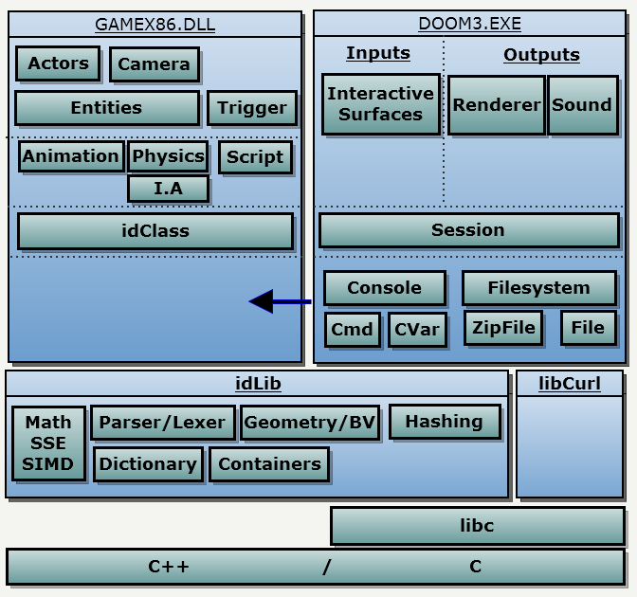

Some essential systems that are needed within the Game project like the Filesystem, and Console are contained within the Engine project. These systems are passed to the Game dll during initialization of the game.

When the Doom3.exe starts up:

* It loads the game Dll into memory via LoadLibrary.
* It gets the address of the GetGameAPI function via GetProcAddress (this is the only exported function from the game Dll)
* Calls GetGameAPI

Once GetGameAPI is called the engine and the game exchange object pointers, so that at the end of the exchange, Doom3.exe has a pointer to the idGame object and gamex86.dll has a pointer to gameImport_t struct that contains references to all the subsystems within the engine that the game might need like Filesystem, etc…. The overall code architecture of the engine is class-hierarchy based. The Doom3 engine and game code is written in C++, and makes good use of abstraction and polymorphism throughout most of the classes. For instance, all classes within the game module are derived from idClass. idClass handles the basic functionality of classes within their game like generating the type information (which allows for RTTI and run time class instantiation through just the classname), saving and loading of basic class information, and processing events.

Some other links to check out before diving into the source code:

* [idTech4 Coding Standard](http://fd.fabiensanglard.net/doom3/CodeStyleConventions.pdf)
* [fully unrolled main game loop](http://fabiensanglard.net/doom3/doom3_unrolled.php)

# Event System

The event system is controlled and managed through the usage of scripts, and two classes’ idEvent and idEventDef. Events can take up to 8 arguments and there are 8 valid argument types. There can be a maximum of 4096 events which are allocated statically in Event.cpp. All of these parameters are controlled through #defines.

#define D_EVENT_MAXARGS 8

#define D_EVENT_VOID ( ( char )0 )

#define D_EVENT_INTEGER 'd'

#define D_EVENT_FLOAT 'f'

#define D_EVENT_VECTOR 'v'

#define D_EVENT_STRING 's'

#define D_EVENT_ENTITY 'e'

#define D_EVENT_ENTITY_NULL 'E'

#define D_EVENT_TRACE 't'

#define MAX_EVENTS 4096

Events are declared by creating an eventDef which lays out the format of the event through strings passed in to its constructor.

const idEventDef AI_FindEnemy( "findEnemy", "d", 'e' );

const idEventDef AI_FireMissileAtTarget( "fireMissileAtTarget", "ss", 'e' );

The first parameter of the constructor defines the name used to invoke this event. This is the call you will see in scripts that use this specific event. The second parameter defines the format of the arguments for this event. This string gets parsed within the constructor and calculates the correct argument size for the event which the idEvent class uses when allocating the data within the event class. The third parameter specifies the return parameter that is returned to the script that invoked the event.

To bind the events to specific callback functions a couple of macros are used that generates the classes RTTI information that doomScript uses to link script function calls to their C++ callback functions.

CLASS_DECLARATION( idActor, idAI )

EVENT( EV_Activate, idAI::Event_Activate )

EVENT( EV_Touch idAI::Event_Touch )

EVENT( AI_FindEnemy, idAI::Event_FindEnemy )

EVENT( AI_FindEnemyAI, idAI::Event_FindEnemyAI )

EVENT( AI_FireMissileAtTarget, idAI::Event_FireMissileAtTarget )

END_CLASS

Check AI_events.cpp for more examples of how events are defined.

# Scripting

For a look into how the scripting VM is architected take a look at this webpage

[Scripting VM Architecture](http://fabiensanglard.net/doom3/scripting_vm.php) .

#define SCRIPT_DEFAULTDEFS "script/doom_defs.script"

#define SCRIPT_DEFAULT "script/doom_main.script"

#define SCRIPT_DEFAULTFUNC "doom_main"

When the game starts up idProgram is fed the default script to compile. This default script contains a number #include directives that tells the compiler to compile those scripts as well. All the compiled scripts are contained within idProgram. Scripts are called from C++ through the usage of idThread. idThread contains a idInterpreter which keeps track of the instruction pointer, call stack, and data stack for that particular script. Each idThread is given real CPU time by the engine each frame allowing the script to execute until it hits a multi-frame event or completes it work for the fame.

Scripts are written in an object-oriented language similar to C++ and are used in many areas of Doom 3. It’s particularly used for entity/map definitions, GUI creation (done in a separate scripting system), Weapon/AI (Monster) behaviors, and scheduling events to occur in the game. For more information on the syntax of the language check out this link: [Script File Syntax](http://www.modwiki.net/wiki/SCRIPT_%28file_format%29). Now let’s take a look at how entity definitions and objects are created in scripts.

Entity definitions are simply a collection of key/value pairs with a name. They are normally used to define entities but can really be used to define anything that just needs a collection of key/value pairs to be defined. The meaning and purpose of these key/value pairs is completely dependent on the type of object it is, but a couple of key/value pairs remain constant regardless of type.

The “spawnclass” key defines the C++ class that spawns this entity. Items use idItem, and monsters use idAI, etc…. Entities cannot be spawned unless the “spawnclass” key is defined.

The “inherit” key tells the game to copy all the key/value pairs from another entityDef. Circular references are not a concern because entityDef’s are only ever parsed once and you will get an error if an entityDef is parsed more than once. The inherit keyword can be very useful for defining base entity types like a default monster or bot.

entityDef monster_zombie_base {

//parent EntityDef

"inherit" "zombie_default"

//Model used for this entity

"model" "model_monster_zombie"

//This key/value pair tells the game to construct a script object

//when spawning this entity.

"scriptobject" "monster_zombie"

//This information is used by idEntity, and idAI.

"size" "40 40 72"

"use_aas" "aas48"

"team" "1"

"rank" "0"

"health" "80"

"melee_range" "32"

"turn_rate" "360"

"mass" "150"

"burnaway" "1.5"

"bone_focus" "headcontrol"

"bone_leftEye" "Leyeaim"

"bone_rightEye" "Reyeaim"

"look_min" "-90 -125 0"

"look_max" "25 125 0"

"look_joint Waist" "0.1333 0.1333 0"

"look_joint Chest" "0.1333 0.1333 0"

"look_joint Shoulders" "0.1333 0.1333 0"

"look_joint headcontrol" "0.6 0.6 0"

"look_joint Ruparm" "-0.4 0 0"

"look_joint Luparm" "-0.4 0 0"

"ragdoll" "monster_zombie_base"

//More information in def file below omitted for space

}